1-XML
# Source: AI Source: Provided by: [Data Path: Persons Table -> ID Column: 1, Name_En Column: Motasem Essam] -> From: [ChatGPT] on [1/26/2026]
XML stands for eXtensible Markup Language. It is a markup language designed to store and transport data in a structured, human-readable, and machine-readable format.

🔹 Key Concepts:
# Source: AI Source: Provided by: [Data Path: Persons Table -> ID Column: 1, Name_En Column: Motasem Essam] -> From: [ChatGPT] on [1/26/2026]
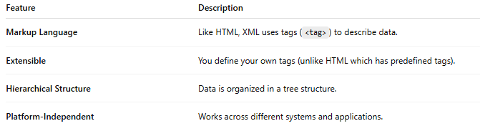
Feature | Description
Markup Language | Like HTML, XML uses tags (<tag>) to describe data.
Extensible | You define your own tags (unlike HTML which has predefined tags).
Hierarchical Structure | Data is organized in a tree structure.
Platform-Independent | Works across different systems and applications.

🔸 Example of XML:
# Source: AI Source: Provided by: [Data Path: Persons Table -> ID Column: 1, Name_En Column: Motasem Essam] -> From: [ChatGPT] on [1/26/2026]

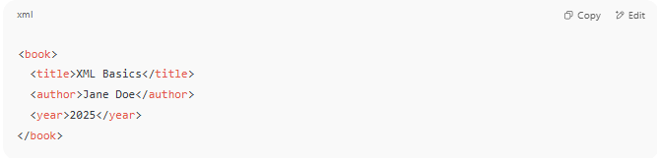
<book>
<title>XML Basics</title>
<author>Jane Doe</author>
<year>2025</year>
</book>

🔹 What XML Is Used For:
# Source: AI Source: Provided by: [Data Path: Persons Table -> ID Column: 1, Name_En Column: Motasem Essam] -> From: [ChatGPT] on [1/26/2026]
- 📦 Data storage (e.g., config files like web.config)
- 🔄 Data interchange between systems (APIs, web services)
- 🗂️ Configuration files (used by applications)
- 📊 Office formats (Microsoft Office files internally use XML)

🔸 XML vs HTML:
# Source: AI Source: Provided by: [Data Path: Persons Table -> ID Column: 1, Name_En Column: Motasem Essam] -> From: [ChatGPT] on [1/26/2026]
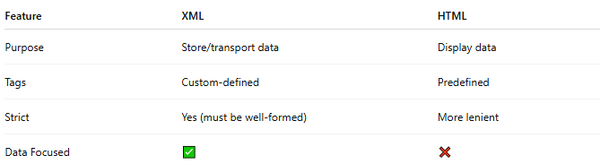
Feature | XML | HTML
Purpose | Store/transport data | Display data
Tags | Custom-defined | Predefined
Strict | Yes (must be well-formed) | More lenient
Data Focused | ✅ | ❌

🔹 Pros & Cons:
# Source: AI Source: Provided by: [Data Path: Persons Table -> ID Column: 1, Name_En Column: Motasem Essam] -> From: [ChatGPT] on [1/26/2026]
✅ Pros:
- Flexible & structured
- Human-readable
- Supported by many tools
❌ Cons:
- Verbose
- Slower to parse compared to alternatives like JSON

🔁 XML vs JSON
# Source: AI Source: Provided by: [Data Path: Persons Table -> ID Column: 1, Name_En Column: Motasem Essam] -> From: [ChatGPT] on [1/26/2026]
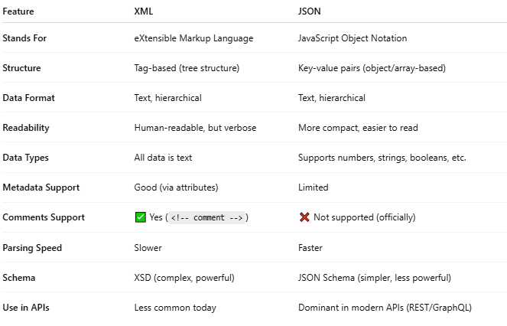

Feature | XML | JSON
Stands For | eXtensible Markup Language | JavaScript Object Notation
Structure | Tag-based (tree structure) | Key-value pairs (object/array-based)
Data Format | Text, hierarchical | Text, hierarchical
Readability | Human-readable, but verbose | More compact, easier to read
Data Types | All data is text | Supports numbers, strings, booleans, etc.
Metadata Support | Good (via attributes) | Limited
Comments Support | ✅ Yes (<!-- comment -->) | ❌ Not supported (officially)
Parsing Speed | Slower | Faster
Schema | XSD (complex, powerful) | JSON Schema (simpler, less powerful)
Use in APIs | Less common today | Dominant in modern APIs (REST/GraphQL)

🔸 Related Technologies:
# Source: AI Source: Provided by: [Data Path: Persons Table -> ID Column: 1, Name_En Column: Motasem Essam] -> From: [ChatGPT] on [1/26/2026]
- XSLT – Transform XML into other formats (like HTML)
- XPath – Navigate XML structure
- DOM – Programming interface for XML documents
- XML Schema (XSD) – Defines structure/validation rules for XML

🧩 What type of markup is XML?
# Source: AI Source: Provided by: [Data Path: Persons Table -> ID Column: 1, Name_En Column: Motasem Essam] -> From: [ChatGPT] on [1/26/2026]
XML (eXtensible Markup Language) is primarily a:
✅ Descriptive / Semantic Markup Language

🔹 Why XML is Descriptive/Semantic:
# Source: AI Source: Provided by: [Data Path: Persons Table -> ID Column: 1, Name_En Column: Motasem Essam] -> From: [ChatGPT] on [1/26/2026]
- XML does not define presentation (no styling, colors, or fonts).
- XML does not define behavior (no commands or procedures).
- XML is all about structure and meaning — you create tags to describe the type of data, not how it looks or what to do with it.

🧾 XML Example:
# Source: AI Source: Provided by: [Data Path: Persons Table -> ID Column: 1, Name_En Column: Motasem Essam] -> From: [ChatGPT] on [1/26/2026]
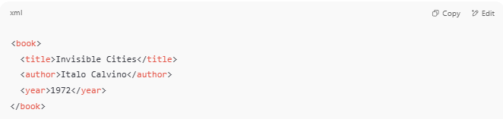
<book>
<title>Invisible Cities</title>
<author>Italo Calvino</author>
<year>1972</year>
</book>

In this example:
- <title>, <author>, <year> describe what each piece of data is.
- There's no instruction to display, format, or process — it's purely semantic.

❌ XML is not:
# Source: AI Source: Provided by: [Data Path: Persons Table -> ID Column: 1, Name_En Column: Motasem Essam] -> From: [ChatGPT] on [1/26/2026]
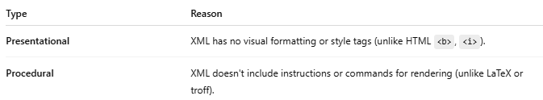
Type | Reason
Presentational | XML has no visual formatting or style tags (unlike HTML <b>, <i>).
Procedural | XML doesn't include instructions or commands for rendering (unlike LaTeX or troff).

✅ Summary:
# Source: AI Source: Provided by: [Data Path: Persons Table -> ID Column: 1, Name_En Column: Motasem Essam] -> From: [ChatGPT] on [1/26/2026]
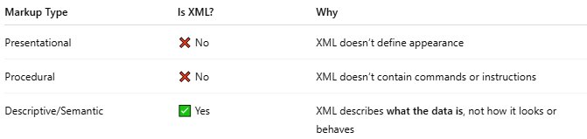
Markup Type | Is XML? | Why
Presentational | ❌ No | XML doesn’t define appearance
Procedural | ❌ No | XML doesn’t contain commands or instructions
Descriptive/Semantic | ✅ Yes | XML describes what the data is, not how it looks or behaves

